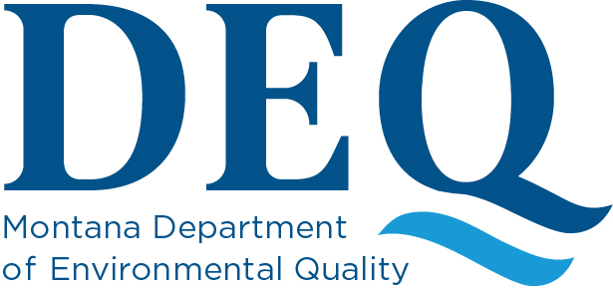

NOTICE OF PUBLIC MEETING BEFORE THE
MONTANA DEPARTMENT OF ENVIRONMENTAL QUALITY (DEQ)

DEQ will hold a public meeting for the Water Pollution Control State Revolving Fund (WPCSRF) Loan Programs on Wednesday, May 27, 2026, at 1:30 p.m. in Helena and online.

DEQ invites public comment on the Emerging Contaminant Intended Use Plan and proposed Project Priority List for State Fiscal Years 2026 and 2027. The Intended Use Plan identifies the intended uses of funds in the loan program and describes how the goals of the program will be satisfied. The Project Priority List identifies projects that are eligible to be funded with loan monies authorized and appropriated to the State of Montana through Federal Fiscal Year 2026 funding.

Public comments may be presented at the public meeting or sent to Mike Abrahamson (MAbrahamson@mt.gov), Water Pollution Control Revolving Fund Program Manager, PO Box 200901, Helena, Montana 59620-0901. Comments must be received or postmarked by June 12, 2026. In addition, communities wanting to add their proposed water pollution control projects to the Project Priority List should contact DEQ prior to the meeting date.

The public meeting will be held in-person in Helena at the DEQ Colonial Building (2401 Colonial Drive), Wilderness Room. A virtual option will also be available using Zoom. To find information on how to join the meeting virtually, or to view the Intended Use Plan, which contain the priority list, contact DEQ at (406) 444-4643 or visit DEQ’s website at: https://deq.mt.gov/water/Programs/eng.

The Department will provide reasonable accommodation for persons with disabilities who wish to participate in this meeting. If you need accommodation, please notify the Department no later than May 20, 2026, to advise us of your need. Please contact Candice Gernand: email Candice.Gernand@mt.gov, phone (406) 444-4643, fax (406) 444-4386.

Rachel Clark, Engineering Bureau Chief
Water Quality Division
Department of Environmental Quality
May 5, 2026

